AI-Augmented Backend Development Project : AI STUDY BUDDY

TITLE : AI STUDY BUDDY

Project Description

AI StudyBuddy is an AI-powered learning assistance platform developed to simplify the study process for students by leveraging modern web technologies and Generative AI. The application provides an intelligent backend system that enables students to upload study materials, generate concise summaries, create flashcards, produce quizzes, and receive personalized study plans through AI-generated responses. The backend is developed using Node.js and Express.js, following a RESTful API architecture that ensures scalability, maintainability, and secure communication between the frontend and backend services. MongoDB serves as the primary NoSQL database, while Mongoose ODM provides schema validation, data modeling, and efficient database interactions. To secure user information and protected resources, the application implements JWT (JSON Web Token) based authentication along with Role-Based Access Control (RBAC). Users are authenticated before accessing AI-powered features, ensuring that only authorized users can utilize premium learning services. Passwords are securely encrypted using bcryptjs, preventing unauthorized access to user credentials.

Scenario

Rahul is a second-year engineering student preparing for multiple semester examinations while simultaneously learning new technical skills for internships and placement opportunities. His study materials are scattered across lecture notes, PDFs, textbooks, online articles, and handwritten notes, making it difficult to organize and revise effectively. Due to the large volume of content and limited preparation time, Rahul often struggles to identify important concepts, create revision notes, and evaluate his understanding before examinations.

Traditional study methods require significant manual effort to summarize lengthy materials, prepare practice questions, and create revision schedules. This process is repetitive, time-consuming, and often results in inconsistent learning outcomes.

System Requirements :
To ensure smooth development, deployment, and usage of the STUDY BUDDY AI-Augmented Backend Application, certain system prerequisites must be met.

1. Software Requirements

Operating System
- Windows 10/11
- macOS
- Linux

Node.js (v18 or above)
Provides a runtime environment for frontend and backend development.

npm (v9 or above)
Package manager used for dependency installation.

Express.js
Backend framework used for API development.

MongoDB Community Server / MongoDB Atlas
NoSQL database used to store:
- User Information
- Chat History
- Documents
- Embeddings
- AI Interactions
- Application Data

MongoDB Atlas Search
Provides full-text search functionality.

MongoDB Atlas Vector Search
Enables semantic search using vector embeddings.

AI Service Provider
- OpenAI API
- Gemini API
- Claude API
- Azure OpenAI (Optional) …etc

LangChain / AI SDK
Used for orchestration of AI workflows.

Browser
- Google Chrome
- Mozilla Firefox

Postman
API Testing

Visual Studio Code
Development Environment

Git & GitHub
Version Control

2. Hardware Requirements

Processor
Intel Core i5 (8th Gen+) / AMD Ryzen 5+

RAM
Minimum 8 GB
Recommended 16 GB

Storage
Minimum 5 GB Free Space

Internet Connection
Required for AI API communication

Display
1366 × 768 or above

Project Architecture

Technical Architecture :

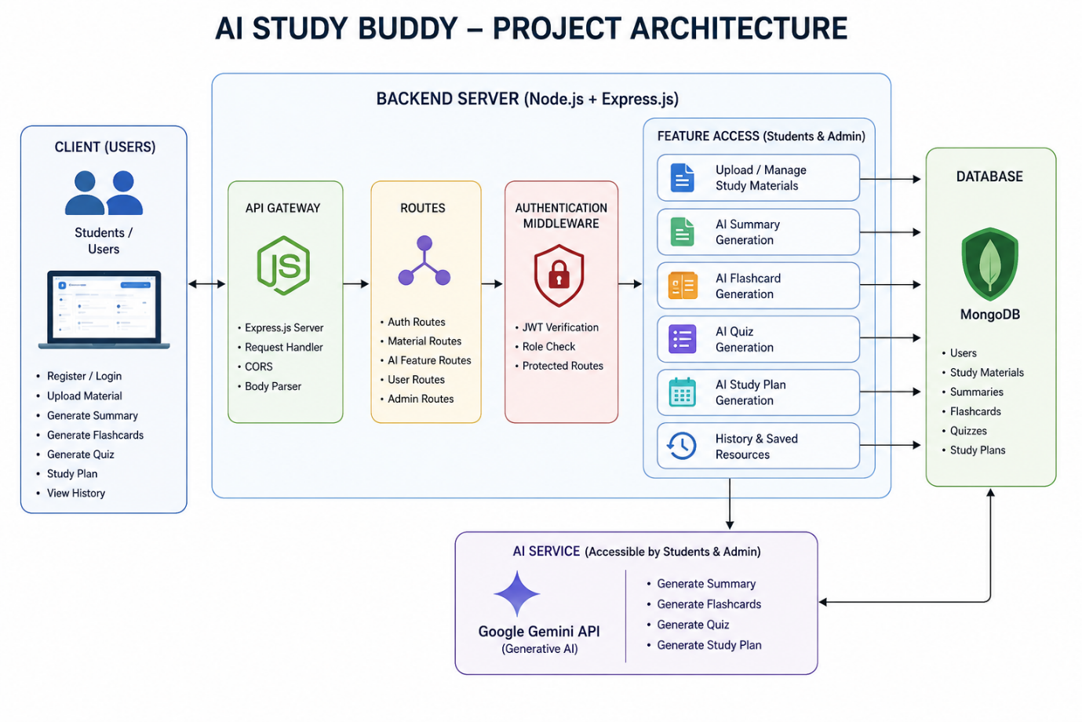Backend Layer
- Node.js
- Express.js
- JWT Authentication
- REST APIs

Database Layer
- MongoDB
- Atlas Search
- Atlas Vector Search

AI Layer
- LLM APIs
- Embedding Models
- RAG Pipeline
- Prompt Engineering

Storage Layer
- MongoDB Collections
- File Upload Storage

Security Layer
- JWT Authentication
- Protected Routes
- Input Validation
- Role-Based Access Control

ER Diagram

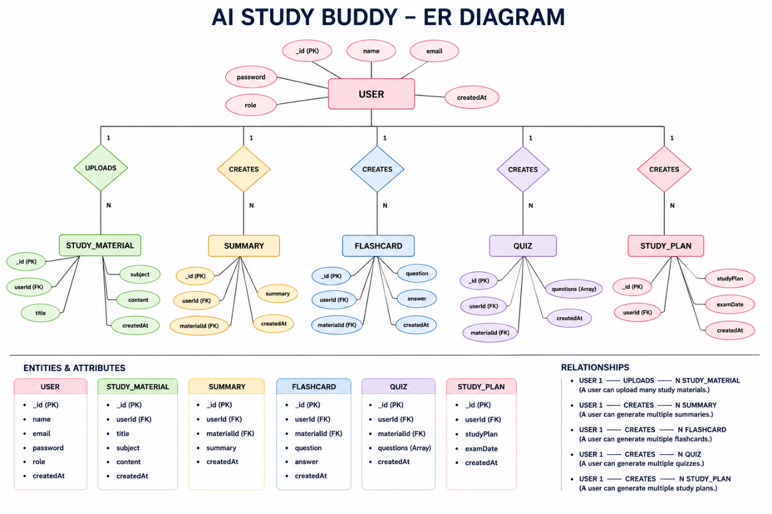Collections

Users
- _id
- name
- email
- password
- role

Documents
- _id
- title
- content
- uploadedBy
- createdAt

Embeddings
- _id
- documentId
- vectorData

Chats
- _id
- userId
- prompt
- response
- timestamp

ActivityLogs
- _id
- userId
- activity
- createdAt

ER Diagram Explanation
Users can upload documents and interact with AI features. Uploaded documents are processed into vector embeddings and stored in MongoDB. Chat interactions and AI responses are logged for future reference and analytics. Activity logs maintain user actions across the system.

Features

Core Backend Features
- User Registration
- User Login
- JWT Authentication
- Protected Routes
- Middleware
- CRUD API
- File Upload
- Role-Based Access Control

AI Features
- AI Chat Assistant
- Semantic Search
- Vector Search
- Document Question Answering
- Text Summarization
- Content Generator
- RAG (Retrieval Augmented Generation)
- Intelligent Insights
- Natural Language Queries

Roles and Responsibilities

Admin
- Manage Users
- Manage Documents
- Monitor AI Usage
- View Analytics
- Configure System

User
- Register/Login
- Upload Documents
- Ask Questions
- Search Content
- View AI Recommendations
- Manage Personal Data

User Flow
- User Registration
- User Login
- JWT Authentication
- Dashboard Access
- Upload Documents
- Generate Embeddings
- Store Vectors in MongoDB
- User Query Submission
- Semantic Search Execution
- AI Response Generation
- Display Results
- Store Chat History

MVC Pattern
The backend follows the MVC (Model-View-Controller) architecture.

Model Layer
Responsible for:
- User Schema
- Chat Schema
- Document Schema
- Embedding Schema
- Activity Schema
Implemented using Mongoose.

Controller Layer
Responsible for:
- Authentication Logic
- AI API Integration
- Document Processing
- Embedding Generation
- Search Operations
- CRUD Operations

View Layer (Routes)
Defines REST API endpoints:

Authentication Routes
- Register
- Login
- Logout

AI Routes
- Chat
- Summarization
- Semantic Search

Document Routes
- Upload
- View
- Delete

User Routes
- Profile
- Dashboard

Advantages of MVC
- Separation of Concerns
- Better Maintainability
- Easy Scalability
- Reusable Components
- Team Collaboration
- Easier Testing

Project Setup and Configuration

Project Structure
Create Project Folder
Inside Project Folder:

Server Folder
Backend Application

Server Setup
mkdir server

cd server

npm init -y
Create:
server.js

models/
controllers/
routes/
middlewares/
config/
services/
utils/

Install Backend Packages
npm install express mongoose cors dotenv bcryptjs jsonwebtoken

npm install openai

npm install multer

npm install nodemon --save-dev

Backend Development
Include:
- Authentication APIs
- JWT Implementation
- AI Service Integration
- Vector Search APIs
- CRUD APIs
- Document Upload APIs
- Chat APIs
Note:
Proper explanation must be provided for every AI API consumed, including:
- Purpose
- Request Structure
- Response Structure
- Cost Considerations
- Security Practices

Database Development
Include:
- MongoDB Collections
- Relationships
- Atlas Search Index
- Vector Search Index
- Sample Documents
Provide screenshots and explanation.

Project Execution

Step 1: Backend
cd server

npm install

Step 2: Configure Environment Variables
Create .env
PORT=8000

MONGO_URI=mongodb://localhost:27017/ai_augmented_db

JWT_SECRET=your_secret_key

OPENAI_API_KEY=your_api_key

Step 3: Run Backend
nodemon server.js
Backend URL:
http://localhost:8000

Output Screenshots
• REGISTRATION

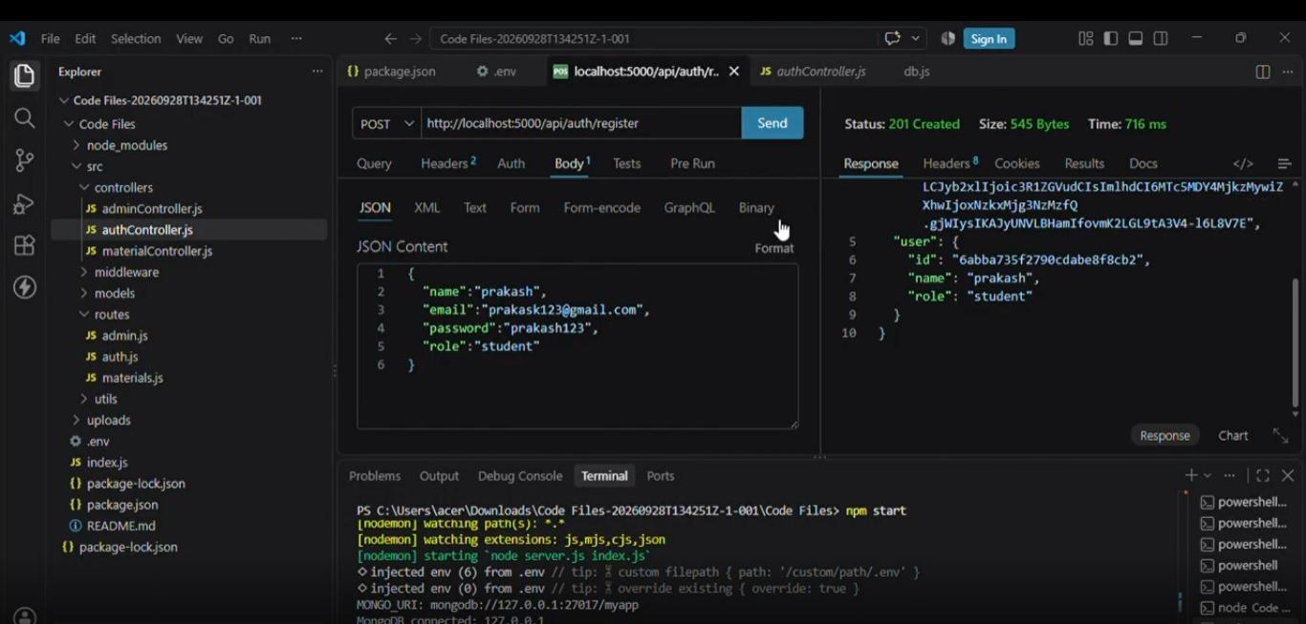

• USER DETAILS

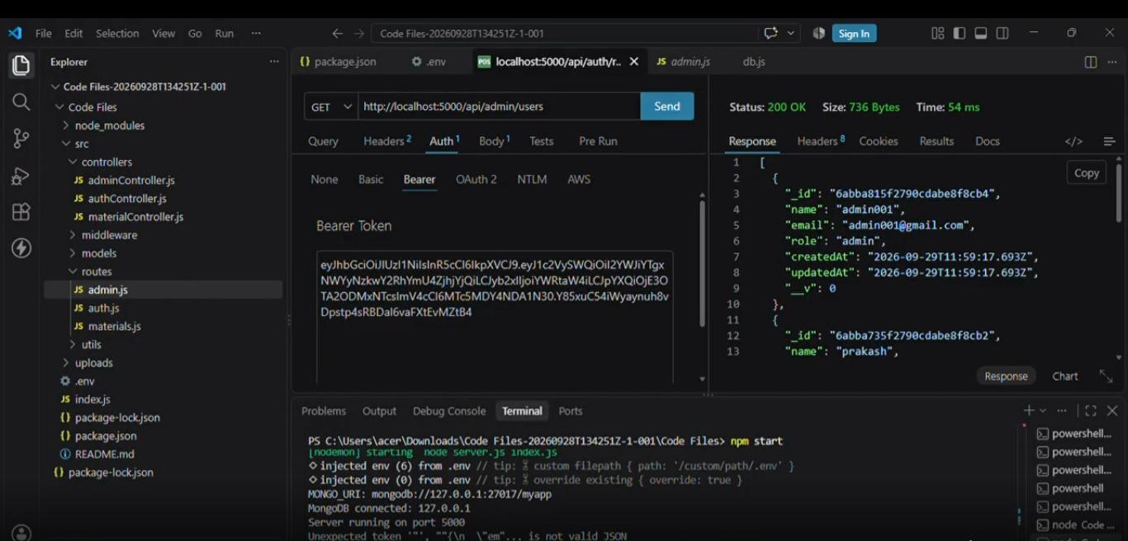

Demo Video Link

https://drive.google.com/drive/folders/1YG60fwG5pYeLmEG4SJHiH8fj4wsfeW6Yource

Code Drive Link
https://drive.google.com/file/d/16yjR58XGWa2t1LE3VubbtNbd8kwA1KLZ/view?usp=sharing

Mandatory Functionalities
- MVC Architecture
- JWT Authentication
- Semantic Search
- MongoDB Atlas Search
- MongoDB Atlas Vector Search
- Prompt Engineering
- AI API Integration
- Role-Based Access Control

